March 21, 2023 – Java Project – Thea Gregory 5291240

Today I worked on the following:

* Populating the Edit Client form.
* Updating the database from the edit client form
* Checking passwords for confirmation

I am happy with my progress, but I have hit a small roadblock in my edit code. I am trying to nest some if statements so that it will be able to determine if the user is updating their password or not, but it does not appear to be going into my else statement. More debugging must be done to fix this. With edit done, Delete will be easy because it’s the same form and a much simpler query to the database. However, I will soon need to add the other tables associated with client and establish properly working foreign keys. I hope to have the View for Restaurant done by the end of the day.

Screenshots:

My problematic code:

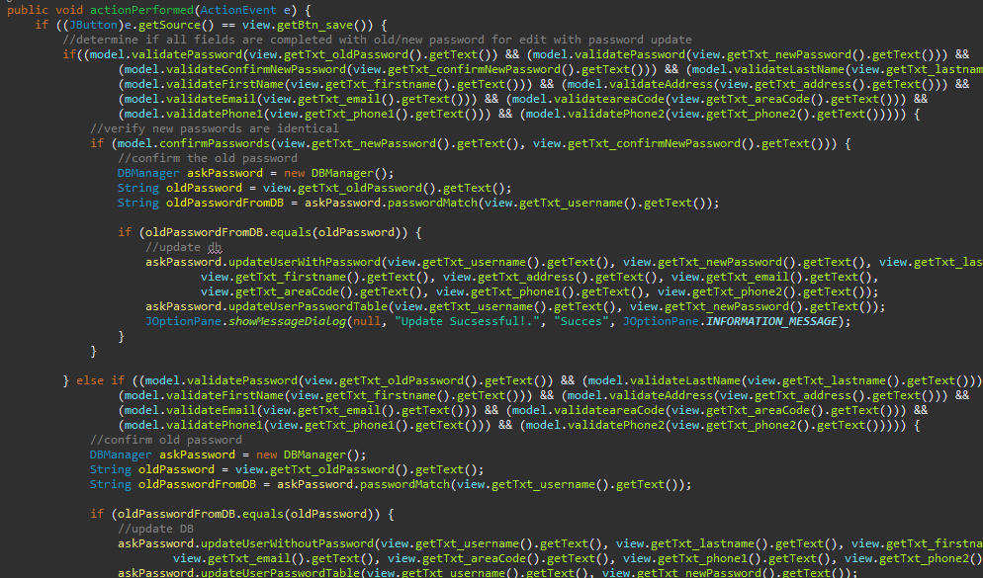

Establishing contact with the database to populate the edit window:

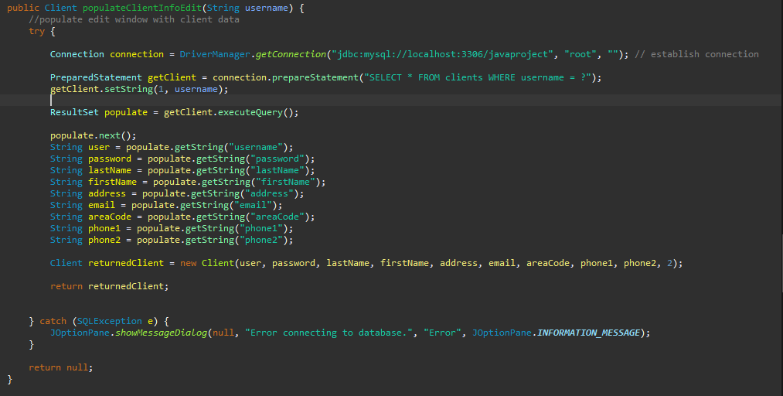

Returning the user’s password from the DB:

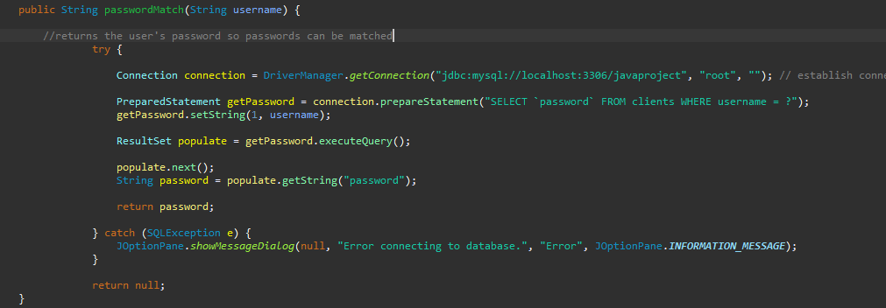

Over the weekend I discovered how to incorporate a JTable into a JOptionPane to give a cleaner presentation:

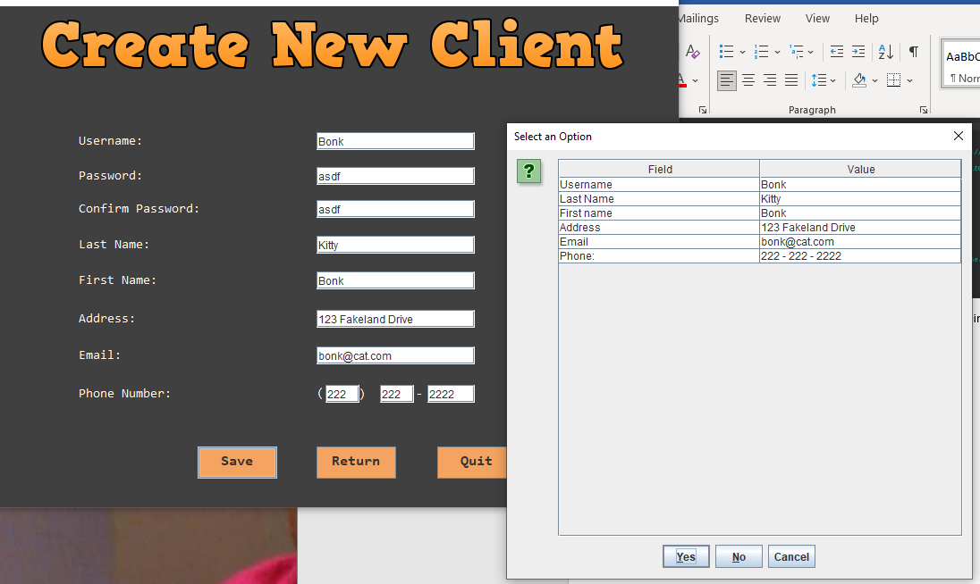

The code to populate Edit Client:

